INTRODUCTION
WHY
- Connect Physical Science principles to Earth Science processes.
- Simulate “cause and effect” relationships… every action, has a reaction.
- Address Next Generation Science Standards (NGSS) and Science, Technology, Engineering,
Mathematics (STEM) national goals. NGSS: simulation model will help identify
interactions, connections, transfer of energy, stability, change, etc. STEM: simulation
model investigations promote inquiry, critical thinking and problem-solving analysis.
WHAT
Self-made kits/models that simulate real-world events.
WHO
Teacher and/or student
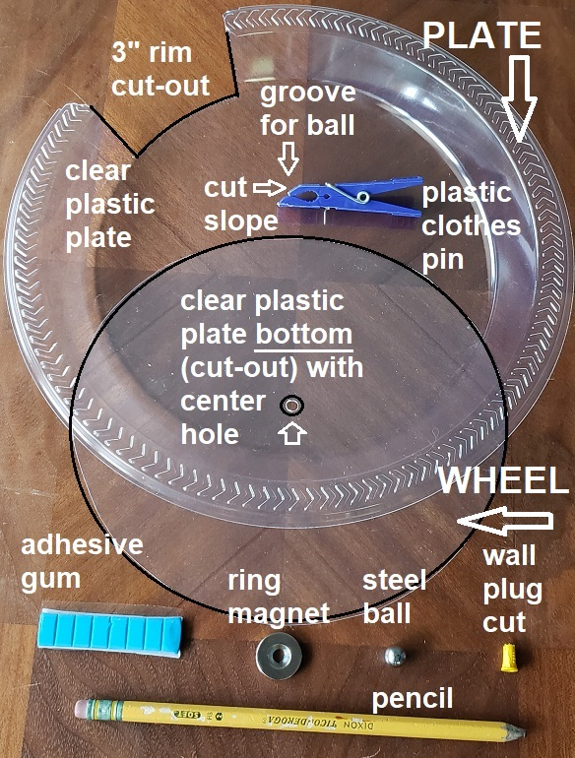
WHEN
Introducing a new science concept, offering visual
and tactical learning lessons, promote student
investigative projects.
WHERE
Classroom or home.
HOW
Projection demonstration, class lab activity, and/or
home-based science project.

PLATE-WHEEL “Make-it” KIT
Construct an easy-to-make inexpensive kit with
common items (photo) found in stores or online.

Presentation
Teacher Activity:
Select class demonstration, class activity, and/or
home assignment and follow set-up instructions.
If using projection technique create overhead
transparency or camera projection copy.
Suggestion: create student “note taking” copy.
Student Activity:
Make event template copy, follow set-up instructions.
Research key concepts noted on template.
Record simulation observations. Draw label, photo,
and/or video project. Display or present project.
Reminder: simulations show concepts and are not necessarily drawn to scale

Set-up
Copy selected lesson Event Templates (p. 3-10) and adapt to grade-level goals.
Materials: two (2) clear plastic plates (about 7” dia.) and scissors or snips to cut plates as shown in Fig. 1 drawings & photo. Cut plate “A”, rim section. Cut plate “B”, “wheel” section. Drill center hole in “B” for “wall plug” pivot (p.10 shows wheel center).
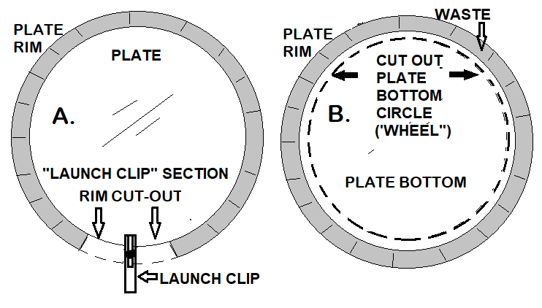
A plastic clothes pin with top groove works
well as a slide or launch platform. Use a
grinder to trim top groove angle (see photo)--
allows steel ball to roll down grooved slope.
Clothes pin “Launch Clip” snaps on bottom of
plate rim—note cut out area on plate “A”.

Use adhesive gum and/or wall plug (cut in
half) for “wheel” pivot. A bead of gum under
wall plug anchors “wheel” in place. Attach
small tape tabs to rotate wheel/template.
Fig. 1
2.

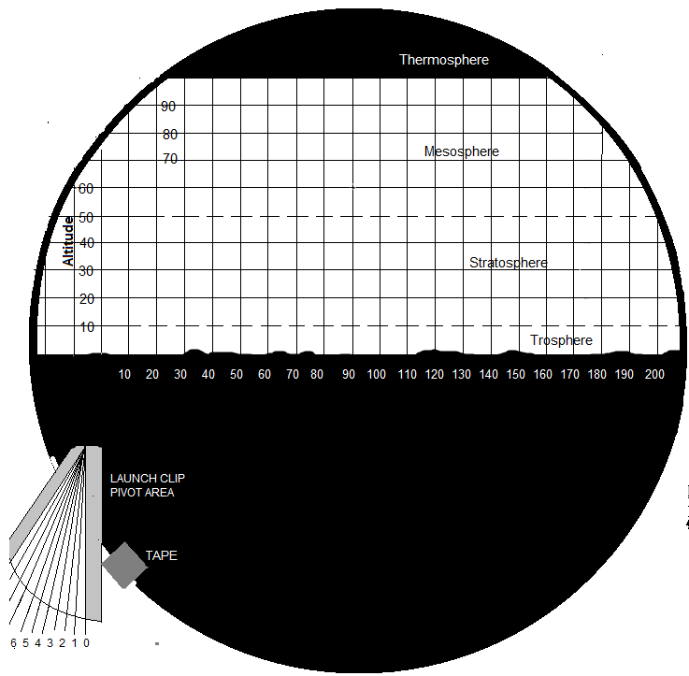

Materials (p. 2 photo): clear plastic plate with cut-out, adhesive gum, ring magnet, cloths pin, steel shot (ball), wall plug, pencil, event template, tape.
Performance expectations: NGSS:MS-PS2-4,5; MS-PS3/4/5;HS-PS2-1/2;HS-P3-1
TRAJECTORY & GRAVITY Video link https://youtu.be/johm9LbDCAM
- Snap on Launch Clip (cloths pin) to cut-out area on plate. Adjust so ball will roll in desired direction--test. Relate path to a rocket, missile, throwing ball, etc.
- Record launch angles for highest altitude, returning 10-100 miles downrange and lowest altitude returning before 200 miles downrange. Record other launch angles and try to predict angle and impact area. Option: Set up a chart and/or graph to plot data.
- Discuss variables affecting launches (wind, temperature, etc.) and simulation variables (launch speed, plastic’s surface, etc.).
- Extension: Design an event template that shows other real-world events.
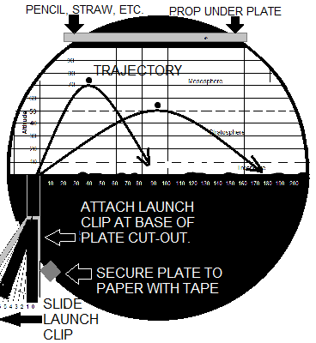

3.3

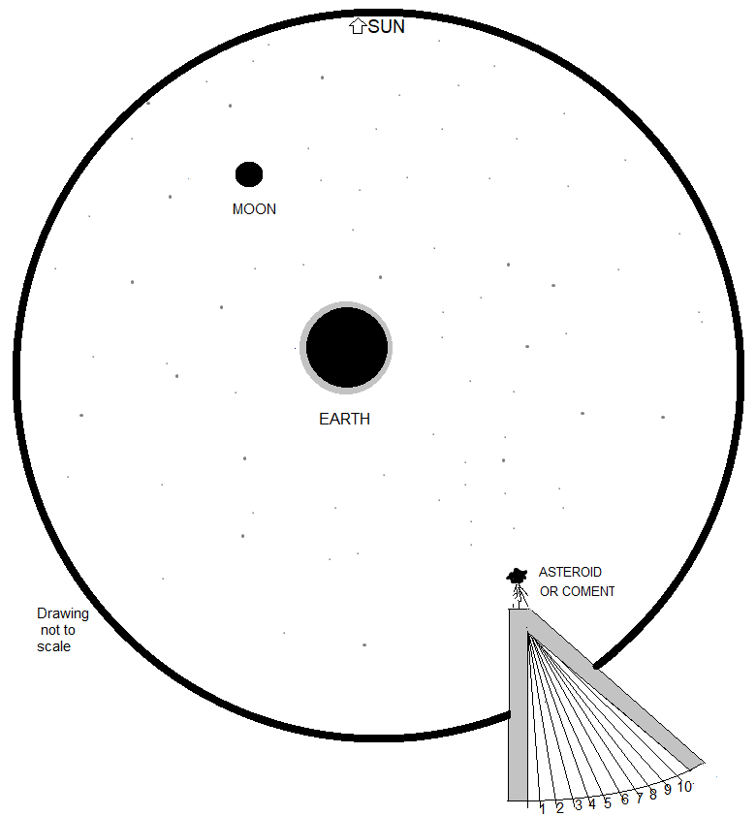

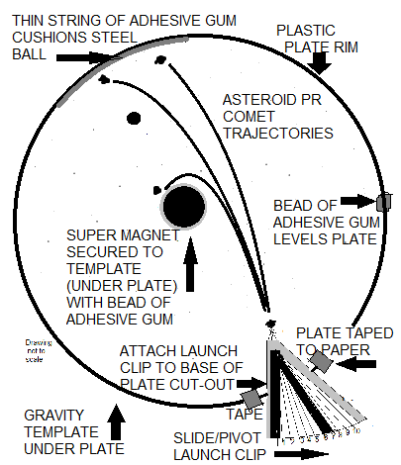

Materials (p.2 photo): clear plastic plate with cut-out, adhesive gum, ring magnet, cloths pin, steel shot (ball), wall plug ,event template, tape.
Performance expectations: NGSS:MS-ESS1-2;MS-PS2;MS-PS3/4/5;HS-PS2-1/2;HS-P3-1
EARTH’S GRAVITY “HIT THE MOON” Challenge
Video Link https://youtu.be/UliNtT2aWtY
- Snap on Launch Clip (cloths pin) to cut-out area on plate. Adjust so ball will roll in desired direction. Relate to path an asteroid or comet heading toward the earth.
- Set wall plug on “moon”. Try to hit it with “asteroid’s” trajectory adjustments.
- Discuss variables affecting the “asteroid’s” trajectory in space and in this simulation (launch speed, plastic floor ripples, etc.).
- Extension: design a “solar system” template placing the magnet at the “sun”.
Add another gravity “field” (magnet)--simulate another planet influence..

4.

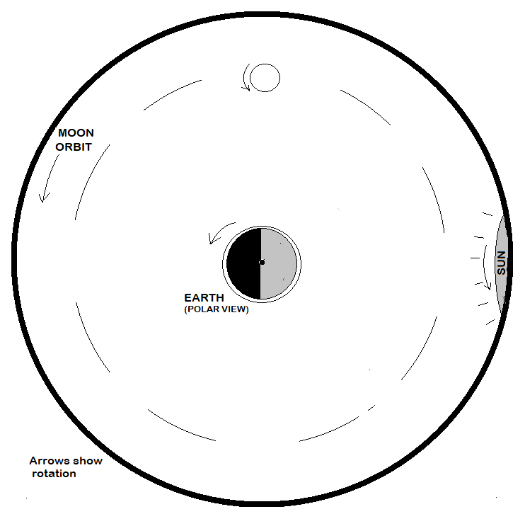

Materials: event template, clear plastic “wheel” (p.2), dry erase or water pen.
Performance expectations: NGSS: MS-ESS1-2/2
MOON PHASES, TIDAL INFLUENCE, ORBIT (Satellites, space junk, etc.)
Video Link https://youtu.be/9NNzyVOKfUE
- Place “wheel” over template. Shade in moon phase (dry erase maker) as viewed from space. Rotate counter-clockwise, redo shading at next position, repeat for four main moon phases. Discuss observations from space and from earth.
- Draw/shade remaining phases (Crescent/Gibbous) as they would appear to an observer on earth.
- Draw, shade, and label ocean “bulges” at Neap Tides and Spring Tides. Discuss.
- Mark on “wheel”: satellites, space station, and space junk orbiting Earth. Rotate.
Discuss orbit variables, including equatorial and polar orbits.

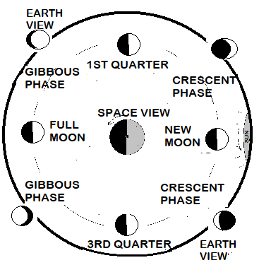

5.

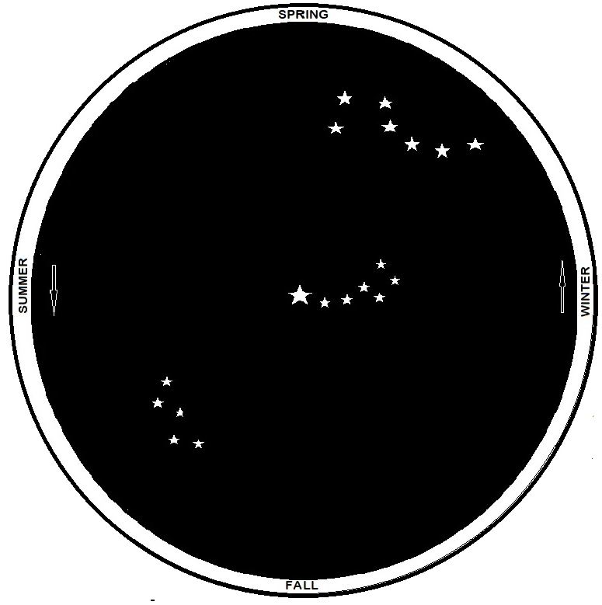

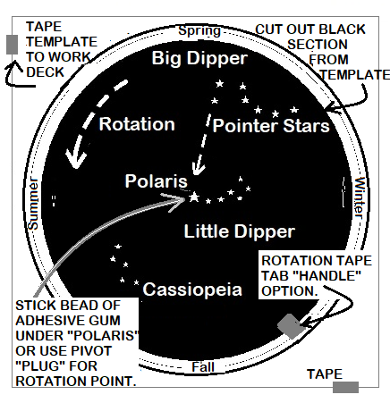
Materials (p. 2 photo): adhesive gum, wall plug, event template, tape. Cut out template as outlined (right)
Performance expectations: NGSS: MS-ESS1-2/2
POLAR CONSTELLATIONS--CLOCK & CALENDAR
Video Link https://youtu.be/Bmr-TpM7AZw
- Begin by orientating Space template (black section), so Big Dipper is in “Spring” position. Explain how to locate the North Star and why it is always in the same general location.
- Rotate Space template 180 degrees or 12 hours. Discuss where would it be at your location and how we can use Big Dipper’s position as a nighttime “clock”.
- Set Big Dipper at another “season” location and discuss how the orientation of this polar constellation can be used as a calendar.
- Extension: design a template that shows south polar constellations.

6..

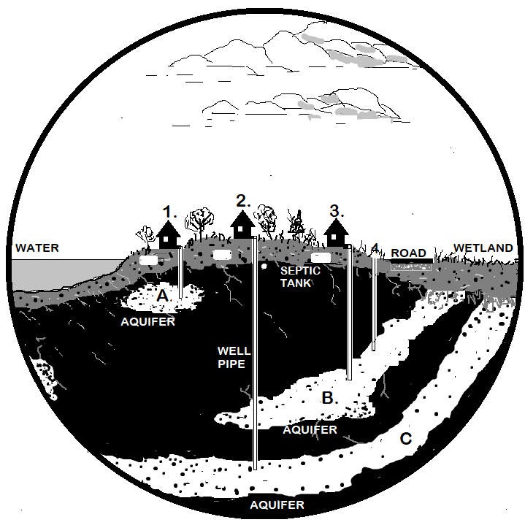

Materials (p. 2 photo): clear plastic wheel, adhesive gum, wall plug, event template, tape. Begin by setting plastic wheel) hole over the center point on the Water Cycle template (see dot).
Performance expectations: NGSS: MS-ESS 2-5/6;3-3/4; MS-PS 1-4;3-5
WATER CYCLE, GROUNDWATER, POLUTION
Video Links https://youtu.be/1txcrjH_Q2U , https://youtu.be/Dd_dyoy_DiI
- Use water pen or dry erase pen to place many dots (water molecules) in the lake. Slowly turn plate “wheel” clock-wise and discuss processes involved in water cycle.
- Continue moving wheel to show “water” entering aquifers. Discuss underground water reservoirs--various types of aquifers.
- Discuss who would be affected if: septic tank leak, uncapped abandoned well, road salts/oil washed into wetland, etc.
- Extension: create industrial site template and show potential effects.

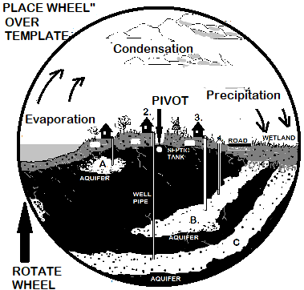

7.8

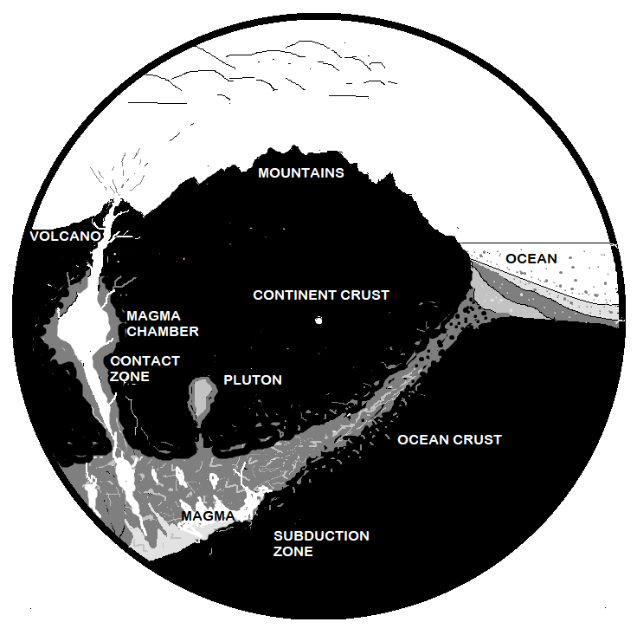

Materials (p. 2 photo): clear plastic wheel, adhesive gum, wall plug, event template, tape. Begin by setting plastic wheel hole over the center point on Rock Cycle template (dot).
Performance expectations: NGSS: MS-ESS 1-4,2-1,2-2,3-1; MS-PS 3-5
ROCK CYCLE, CONVEREGENT ZONE, SUBDUCTION ZONE
Video link https://youtu.be/ZMiGPWcUZ18
- Use water pen or dry erase pen to place many dots at volcano and at mountain tops. Slowly turn plate “wheel” clock-wise and discuss ash/gas eruption & weathering of mountain rocks (forming sediments).
- Continue moving wheel to show deposition in ocean (sedimentary rock), intense heat and pressure at boundary (metamorphic rock), and meting and colling of magma (igneous rock).
- Create a template showing a divergent/divergent boundary. Discuss plate tectonics, continental drift, rift volcanoes, sea floor spreading, etc.

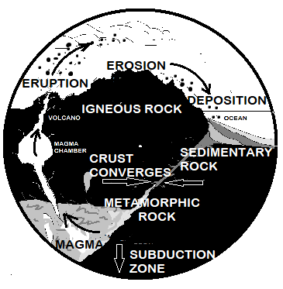

8.

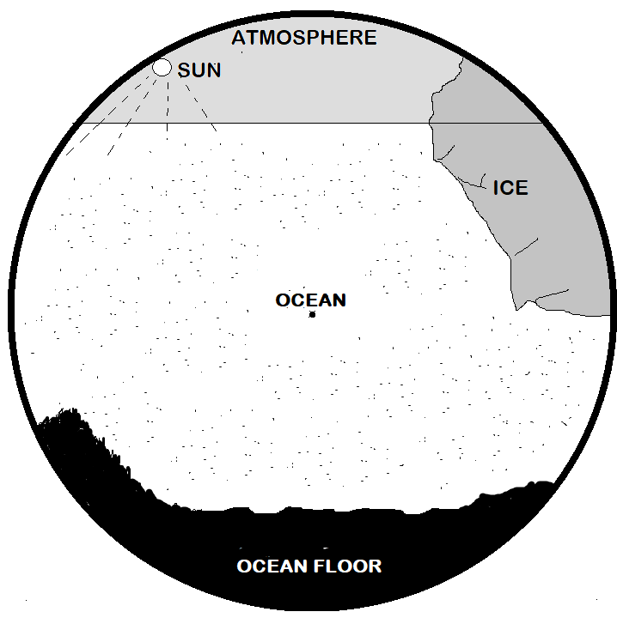

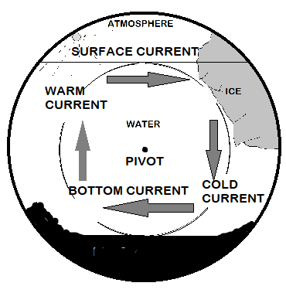
Materials (p. 2 photo): clear plastic wheel, adhesive gum, wall plug, event template, tape. Begin by setting plastic wheel hole over the center point on Rock Cycle template (dot).
Performance expectations: NGSS:MS-ESS2-1/4; HS-ESS2-2/3/4
OCEAN DENSITY CURRENTS
Video link: https://youtu.be/9bMdIxQjKRc
- Use water pen or dry erase pen to place many dots next to “ice”. Slowly turn plate “wheel” clock-wise and discuss cold sinking arctic water currents move along the ocean floor.
- Continue moving wheel to show rising warmer tropical currents eventually moving along surface area (convection currents).
- Extension: illustrate how sea floor currents are affected by floor topography, salinity, turbidity, wind, etc.

9.

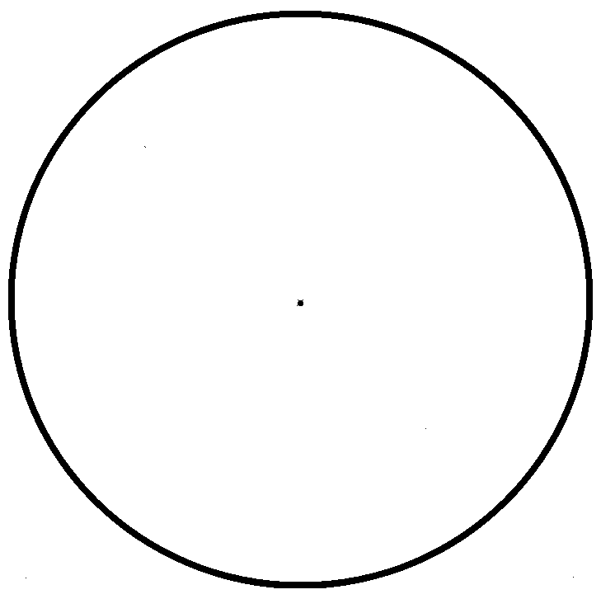

Use blank template to create lesson extension(s)
NOTES:
10..

